

SWAT Team Success: Lessons Learned from the Nortel Networks Account, Plaid contract ASD SWAT Team

White Paper

Author: Peter Donnelly
Computer Sciences Corporation

Document Revision History

Date | Description | Revision #
June 21, 2002 | Original draft (Peter Donnelly) | 0.1
June 26, 2002 | Distribution for management input (P. Donnelly) | 0.2
June 30, 2002 | Completed document- 1st distribution (P. Donnelly) | 1.0

Table of Contents
Background 3
Mission and Mandate 3
Team Scope 4
Approach 4
Team Member selection 5
Team Structure 6
Geography 7
Operational Approach 7
Opportunity Identification 7
Opportunity Analysis 8
Solution Delivery 8
Communications 9
Activity Summary 10
Team Deliverables 10
Applications Supported 11
SWAT Team Success 14
Lessons Learned 14
Team Structure and Size 15
Key Lessons 15
Recommendations for Future Teams 15
Mandate and Approach 16
Key Lessons 16
Recommendations for Future Teams 16
Scope and Duration 16
Key Lessons 16
Recommendations for Future Teams 17
Troubleshooting 17
Key Lessons 17
Recommendations for Future Teams 18
Communications 18
Key Lessons 18
Recommendations for Future Teams 19
Team Member effectiveness 19
Key Lessons 19
Recommendations for Future Teams 20
Resource Utilization and Work flow management 20
Key Lessons 20
Recommendations for Future Teams 21
Support Model Transition (PLAID) 21
Key Lessons 21
Recommendations 22
Conclusion 24
Appendix A – PLAID Support Categories 25
Appendix B - SWAT Supported applications 27
Appendix C – SWAT Documentation 28

Background

When the Nortel contract with CSC was reduced by approximately 50%, a complete reorganization of the ASD team was required to be able to continue to deliver service. With the new contract being signed by the client mid December 2001 with a fixed commencement date of January 1, 2002, the timelines were very short and the CSC management team rallied to complete a radical restructuring effort within three weeks in December 2001.

Through the contract, there was an acknowledgement from both the Nortel and CSC executive that certain transitional teams would be required to assist the support personnel and ensure there was minimal service impact to the Nortel business units. One of these transitional teams was the SWAT Team.

Mission and Mandate

The SWAT Team was chartered to assist the CSC-Nortel Account Support teams with the support of Nortel’s business through the critical transition period. The SWAT Team maintained a steady staffing level of 28 Full-Time People (FTP) over a six-month period from January 1, 2002 to June 30, 2002.

At inception, the SWAT Team’s official charter was tabled and accepted as follows:

To identify targets, quantify opportunities and execute strategies throughout ASD on the Nortel Account that would:

1. Directly deliver measurable reductions in support requirements and Remedium ticket volumes.

2. Reduce or prevent the occurrence of high business impact issues.
3.
Implement stabilization methods, including changes based on process, data, infrastructure, and/or business application
4.
Reduce current operational, support or data management functions required to support Nortel’s application infrastructure.

It is key to note that the SWAT Team’s mandate was to identify above opportunities, analyze the situation, recommend a solution, demonstrate return on investment (ROI), identify the project requirements, and deliver the solution into production. In this mandate, the SWAT Team was neither simply a consulting team (providing recommendations for others to enact) nor a project team (delivering on existing project requirements). The SWAT Team had end-to-end responsibility for its products and its success and was further responsible, and empowered, to deliver effective solutions that met the ROI expectations of both the CSC Account Executive and the Nortel client.

Team Scope

The SWAT Team’s scope was to assist in defining the
operational scale of the Team’s activities and the Team’s scope was defined as follows:

In Scope

-All CSC supported Nortel IS applications globally in Support Categories A, B and C.

-Execution of approved Remedium ticket reduction strategies.
-Execution of support reduction strategies.
-Delivery of targeted point solutions for application reliability improvements.

Out of Scope

-All Support Category D and non-CSC supported applications.
-Implementation of Nortel corporate strategies (including security, decommissioning, business process implementation, application feature enhancements, and new application deployment).
-Day-to-day operational support.
-Severity independent outage and issue resolution.

In essence, the SWAT Team was a fully funded organization defined to be a mobile troubleshooting team that would identify immediate and near term opportunities. It delivered operational improvements, support cost savings and reduced the impact of the Plaid transition to Nortel’s business units. This was in large part possible due to the fact that the team operated without responsibility of handling
day-to-day operations or requiring lengthy approval to undertake improvement opportunities.

Approach

With the mandate of providing emergency assistance to over 600 business applications, globally dispersed, utilizing over 100 different technologies, the SWAT Team had a daunting task ahead to be able to provide knowledgeable and timely response to such a large environment. Thus, the Team was strategically structured to be flexible, responsive and maneuverable.

To provide maximum value, the SWAT Team closely held two key tenants on every opportunity that was resolved. First, the objective through resolution was to eliminate the recurrence of the issue and not to simply fix the immediate issue itself. Generally, the SWAT team worked in partnership with the existing support team to immediately return a failed application to functionality. The true value provided by the SWAT Team was the completed analysis that determined the root cause of an issue and implemented a solution that would eliminate its recurrence. Second, the SWAT Team ensured that on every solution implemented, full activity documentation was kept and knowledge transfer was undertaken with the support prime(s) to ensure that their learnings were not lost. This served not only to help the support prime(s) better understand their application, but also to assist them in troubleshooting the environment on subsequent issues.

Team Member selection

Team members were chosen primarily for their breadth of technology knowledge and adaptability to change. Without question, these two elements proved to be crucial to the successful contribution of the members. As secondary criteria, the team was screened to identify members with strong knowledge of Nortel’s business, breadth of experience with various applications, and past performance.

The team of twenty-eight was chosen to represent the majority of the technology areas that may require support with additional depth of knowledge in key technology areas such as web based technologies and MPE/mainframe support. The team members were primarily application developers and Level 3 support primes but also contained experienced DBA’s, application architects, a senior technical writer, and senior project managers.

Despite the careful selection of technology skills, over the course of the Team’s mandate, it was found that certain skills were very difficult, if not completely unavailable to staff. On the Nortel account, those skills included WebObjects, Business Objects, Oracle Financials, Cognos Powerplay, and various legacy mainframe languages. Without these technical skills, the SWAT Team discovered that they could not always provide value and resolve critical issues that arose within those environments.

While the team membership changed over the six months to meet the technology and project requirements of the Team, there was a core group of 12-15 members who remained on the team as their flexibility and knowledge made them invaluable to tackle virtually any issue that may arise. Over the course of the six months, the overall turnover was about 100%, with over 55 people working at some point on the SWAT Team.

Team Structure

One of the key difficulties encountered was to have the right skillset available when and where required. To accomplish this, the team was structured as a matrixed team that utilized experienced project managers to select required team members from the available pool for the opportunities assigned to them by the Queue Manager. All work assignments came through the queue manager.

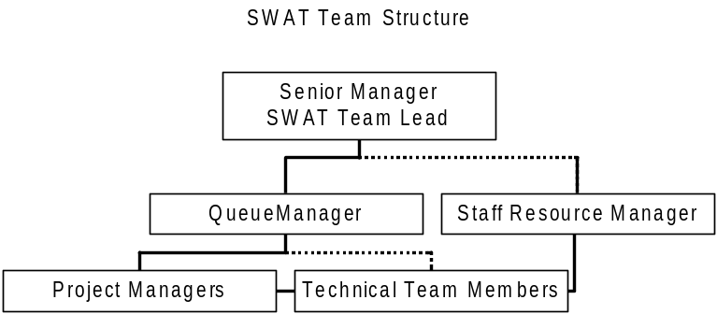
Figure 1: The technical team members had a direct reporting relationship to their Project Manager(s) on day-to-day activities and operational deliverables as well as their Resource Manager for performance and career management and a dotted line relationship to the Queue Manger. The Resource Manager was not a member of the SWAT Team, but reported into the Resource Management organization.

The Queue manager also managed the team skills matrix and resource assignment spreadsheet (RAS). These tools tracked the skill sets and current assignments and availability of the team members. The skills matrix was used by the Queue manager and project managers to identify the team members with the required skill set(s) for a given task, while the RAS was used to track the percentage availability and assignment end dates of all staff.

As assignments were identified in the SWAT queue, the Queue Manager would assign them to an available project manager who would work with the client to further identify the opportunity. The project manager would then use the skills matrix and RAS to identify and ‘reserve’ the resource(s) required. The team members themselves would not have a dedicated project manager but would report to each project manager on their specific tasks.

As required, specific project teams were initiated to accomplish either strategic team initiatives or complete large projects. Again, these teams were formed from the available staff in the matrixed model. Some such teams included the initial Statistical & Data Analysis team and Executive Interview team which were created in early January to identify high value opportunities, as well as various project delivery teams.

Please note that the Nortel account employs a Resource Management model that provides all staff and managers with a dedicated resource manager. This supported the SWAT Team’s matrixed model, ensuring that the employee had stable reporting management as they moved from task to task.

Finally, it is worth noting that several team structures were discussed and utilized prior to settling on the above model. All other models (including providing assigned technology skill set teams, having dedicated management face-offs to specific clients, having technical staff reporting to a single coordinating project managers, etc.) proved themselves to be more limiting than helpful in accomplishing the objectives of the SWAT Team.

Geography

As Nortel’s application environment and clients are globally dispersed, some consideration was given to ensuring that the team was able to address issues with some local representation when appropriate. However, due to the availability of skilled resources and as application support can be provided from anywhere to anywhere with virtually equal effectiveness, the Team’s geography was governed primarily by the location of right team members and not the location of the servers or clients.

The SWAT Team’s distribution was roughly 30% US based and 70% Canadian with always one team member in AsiaPac. Specific Asia/Pacific Rim representation was required as the 12-4 hour time difference and language differences made communications difficult from North America.

Operational Approach

In order to effectively deliver service, the SWAT Team’s approach was to provide not only direct support of application issues but also to engage in impact and situational analyses and focused projects.

However, all opportunities, regardless of their nature or source followed a well-defined three-step process of Opportunity Identification, Opportunity Analysis, and Solution Delivery.

Opportunity Identification

Opportunities for the SWAT Team came in from four main sources:
- Statistical Analysis of ticket, troubleshooting and RCA data.
- Identification of high business impact areas from Nortel or CSC senior management.
- Requests for assistance from Operational and support primes.
- Direct interviews with clients or support primes, and direct knowledge of SWAT Team members of opportunity areas.

Each opportunity required a ticket to be opened in the SWAT queue and would include information on the source of the issue, it’s symptoms, and it’s urgency and impact.

The Queue Manager would then initially assess and prioritize the issues and assign them to a project manager or senior technical lead for Opportunity Analysis (depending on the complexity and estimated size).

Opportunity Analysis

Here the opportunity would be reviewed and three work products produced. First, a detailed problem summary and solution statement would be generation. Second, a rough order of magnitude (ROM) would be developed to outline the time and effort required to resolve. Third, a value proposition would be defined that would outline the benefits to CSC and the client.

The value proposition identified what would be reduced through resolution of the issue. This was normally identified in terms of support tickets eliminated or avoided (number of tickets per week), ongoing operational effort saved (hours of effort saved per week), Severity One outages avoided (number of outages per year- primarily for Category A applications), and client revenue impact (thousands of dollars per quarter).

From this the ‘ROI’ (return on investment) could be determined. If the ROI was acceptable, then the Swat Team Lead would approve the opportunity for Solution Delivery.

Solution Delivery

Depending on the size and complexity of the solution, a single technical prime would be assigned or a project team would be assembled to deliver the solution. If technical expertise was required that was not immediately available on the team, someone with the required expertise would be brought into SWAT or the expertise would be leveraged from either the steady state teams or from the client.

Once developed, the request originator, the Nortel approver, or an approved Support Manager, as appropriate, would grant acceptance of the solution.

Please note that all projects over 80 hours would complete full Repeatable Project Management (RPM) Lite documentation.

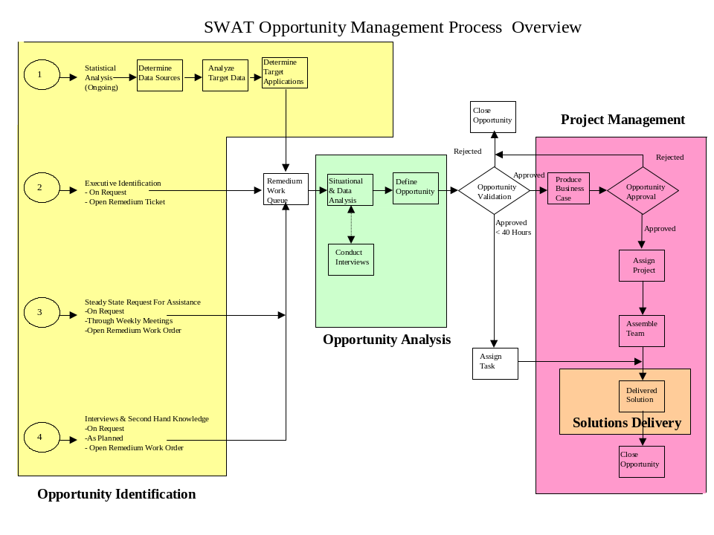
Figure 2: The process was fluid so as to minimize approval time. Small project could gain approval within minutes. Weekly reviews of all projects were established to approve larger opportunities and emergency sessions could be called at any time.

Communications

As the concept of the SWAT Team was new to the Nortel clients as well as to the CSC ASD team, an extensive communication program was initially undertaken to ensure that the objectives of the SWAT Team were properly communicated.

Interviews and focused calls were placed with key management within CSC and Nortel, focused emails identifying the SWAT engagement process were sent to all support managers and staff and SWAT representatives attended all ASD DSRs and Operational Reviews.

While there was little understanding initially of the team’s role on the Nortel account, within the first two weeks of 2002, there was strong engagement of the SWAT team from all levels as the benefits of the model and the support the team offered was better understood.

As the support structure evolved and the needs of the business changed, ongoing attendance on the DSRs (Daily Service Reviews) and Operational Reviews continued to play an important role in the alignment of the SWAT Team’s activities with the current business requirements.

Activity Summary

Over the course of its six month mandate, the Nortel Account SWAT Team saw it’s activity focus shift as the needs of Nortel’s business, and the operational maturity of the support teams, evolved.
In first three weeks of January, focus was divided between three main objectives:
- strategic analysis of the Resolved ticket flow by application and resolution type,
- directed ‘discovery’ interview process to identify problem areas, and
- delivery of a select group of identified operational improvement targets.

By the end of January, this quickly migrated to a twofold approach of: 1) targeting the resolution of Severity One, ‘HOT’ items that were identified by Nortel and CSC at the twice daily DSR calls that were then being held, and 2) identifying and eliminating (recurring) operational issues prior to them become business impacting to Nortel.

Over the next 3 months the SWAT Team worked primarily to restore these business-impacting outages to service and identify and eliminate any recurring issues.

As the CSC support and SWAT Teams were able to settle Nortel’s application environment, the SWAT Team naturally moved to undertaking strategic projects, most of which were identified either through the earlier discovery interviews or through the resolution of the HOT items.

Finally, throughout June, the SWAT Team worked to complete its strategic initiatives and ensure that all application knowledge and support was transferred to the steady state team(s). The thrust here was to minimize the impact on the support environment of the removal of the SWAT Team at the end of its term.

Team Deliverables

Over the course of its mandate, the CSC-Nortel Account SWAT Team was engaged in over 250 circumstances covering over 100 different applications. Further, the SWAT Team delivered:

- 153 technical and critical issue solutions.
- Support of 84 ‘trouble’ applications.
- Resolution of over 40 HOT (high Nortel business impact) issues.
- 20 Root Cause Analysis (RCA)/situational analyses.
- 15 detailed application statistical ticket analyses
- Interview module that conducted 35 targeted discovery interviews

As can be seen by the above, the SWAT Team provided not only direct support of applications in productions, but additionally provided significant impact and situational analysis data, and focused discovery/improvement projects.

Having this wide distribution of approaches allowed the SWAT Team to ensure that there was a continuity to the flow of work

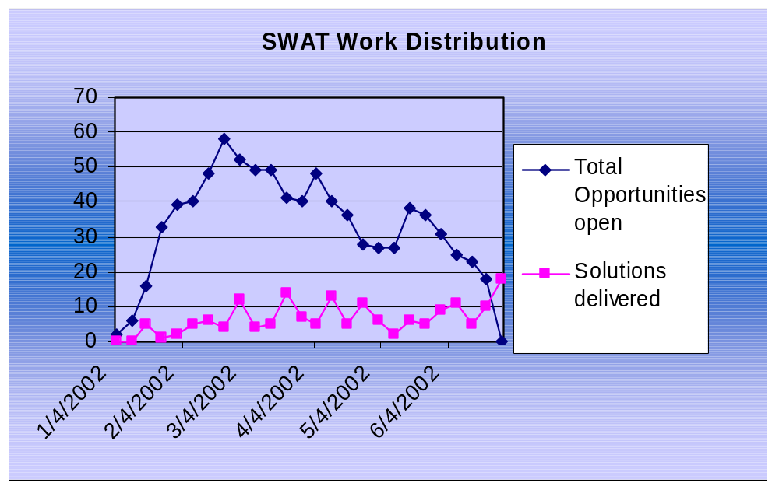

Figure 3: SWAT Team ramped up through January and maintained a relatively stable flow of work throughout its mandate. In its last month, SWAT focused on closing existing opportunities and deferred new work to the then established CSC FMO (Fulfillment Management Office) project delivery teams.

Applications Supported

On the Nortel Networks account, the applications supported by CSC were categorized as either A-business critical, B-business tolerant or C-non-critical. (For a detailed description of the PLAID contract and account support categories, please see appendix A).

Category A applications generally required dedicated resources with a high degree of application specific expertise. As there was a higher number of support available for Category A applications resources (often providing 7x24 support and monitoring), the SWAT Team was called upon least in this area.

Category B applications provide critical data feeds or business sensitive functionality for Nortel and usually have 5x8 operational monitoring. As such, these applications made up the bulk of the focus for the SWAT Team. It is this application set that, at Nortel’s request under the new PLAID contract, endured the greatest reduction of operational coverage and support personnel assignment.

Category C applications required less support than the Category B applications as they tended to be either low usage or stable and non-critical. This being said, there were numerous critical issues with Category C applications where the SWAT Team was engaged. However as there are by far the largest number of applications in Category C, this category could be said to have relatively stable.

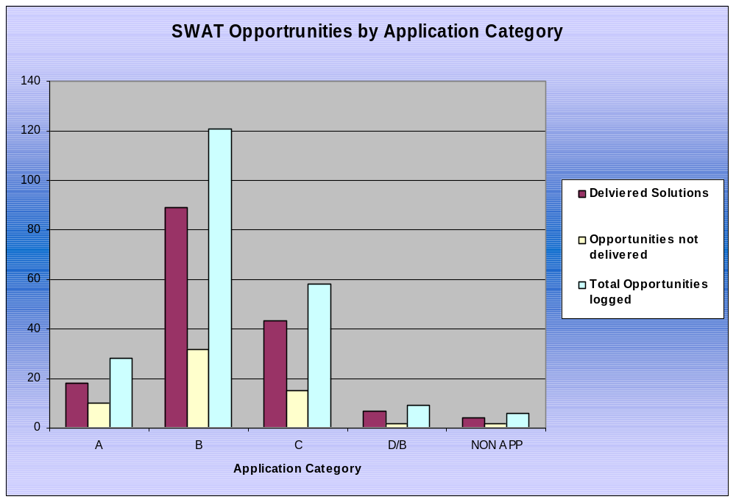

Figure 4: Category B applications made up over 50% of the SWAT opportunities. ‘NON APP’ items were engagements not directly in support of an ASD supported application (e.g. Nortel retained application or GIS application)

SWAT was engaged over 250 times to provide support, but did not always deliver a solution to production. 153 solutions were delivered and identified opportunities that were declined were usually due to an insufficient ROI on the activity, or the issue was resolved during the SWAT investigation process.

In several other cases, SWAT was not able to deliver a solution as the team lacked the required technical skills. In these cases however, SWAT would often backfill the technical support prime with the required skill allowing them to develop and deliver the solution.

While in most cases SWAT was engaged on an application only once or twice to solve critical issues, there were thirteen applications that required SWAT involvement up to 8 times. Analysis of these applications showed that they were ones that had previously enjoyed the highest number of support resources prior to the Plaid contract and thus had the largest number of manual processes that required automation under the new contract. In addition, as most of these applications feed Nortel mission critical systems, the impact of any failure data processing delay was immediately felt (and escalated) by Nortel’s business units.
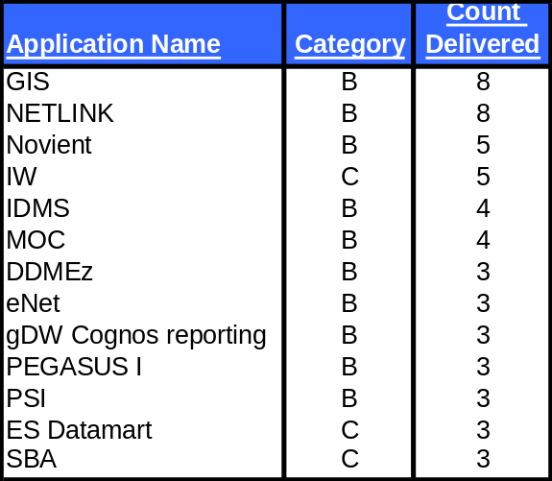

Figure 5: Applications with highest number of engagements.

Overall, the SWAT engagement was very representative of the support environment and the maintenance requirements of the applications themselves. Most engagements came from application sets which were expected to be impacted by the support change. In other words, the issues that were anticipated occurred as per management projections, thus requiring the engagement of the SWAT Team as anticipated by its existence during the transition phase of the PLAID contract.

SWAT Team Success

The CSC-Nortel Account SWAT Team was extremely successful in achieving its objectives. SWAT Team staff and management received the complete support of the CSC executive team and the client in their tasks and innumerable messages of recognition for their achievements. Probably the biggest measure of success of the Team and the approach was the fact that the client would unhesitatingly request the SWAT Team get involved in all the most critical issues, always citing confidence that the Team could assist in quickly brining it to resolution.

- Savings of over 850 recurring technical issues (tickets) per month
- Greater than 600 hours per month of operational support per month saved.
- Number of intangible benefits including:
  - Avoidance of untold outages and elimination of future tickets.
  - Direct avoidance of an estimated $50M in Nortel business impact
  - Quick closure of Severity One HOT issues
  - Provision of applications support, training and knowledge not elsewhere available

The benefits delivered by the SWAT Team were a critical component that, combined with the exceptional efforts of the steady state support teams, made the difference in being able to support the Nortel applications environment with a significantly reduced work force.

Lessons Learned

There were innumerable learnings gained during the initial transition phase of the Plaid contract on the CSC-Nortel account. The implementation of the aggressive and groundbreaking support structure, of which the SWAT Team was a part, demonstrated what could be accomplished when a focused and comprehensive plan of change is implemented and rigorously followed with strong client partnership.

Throughout its mandate, the SWAT Team broke new ground in partnership with Nortel and provided many valuable lessons. Categorized below are the most salient lessons pulled from the innovative SWAT model.

Each area will identify the key lessons, and recommendations for future ‘SWAT’ initiatives.

Team Structure and Size

Key Lessons
- The Nortel account SWAT Team had a steady run rate of 28 FTP over six months. The team would have been more effective had the staffing budget been designed to allow an average of 28 FTP over six months. This would have allowed additional people to be brought on during the key ‘hot’ item troubleshooting times and reduce staffing at the beginning of the mandate when objectives and staffing requirements were still being drawn. This being said, the staffing would have to be closely monitored against deliverables and effectiveness in this scenario to ensure that staffing does not unreasonably ‘balloon’ and squander resource funding.
- For what was required on the CSC-Nortel account, 25-30 FTP was an adequate size. While up to 50 people would have been required to cover all skill sets at one time, the lower number ensured that SWAT management was working hard to utilize only the right people, with the right skills, at the right time. SWAT troubleshooting teams were usually 1-4 people, but it was found that at least 12-15 available staff were required to cover the most common skill sets that could be applied to any situation.
- The matrixed management structure appears to be the most effective structure for the team. This provides the necessary flexibility and access to people and skills required to quickly address any issue that may arise. As any issue involving any technology of business application could arise at any time, there was not always the ideal team member available on which to address this issue. This matrixed model allowed those assigned to a task (management and technical) to freely pull people from elsewhere on the team for advice and assistance without needing management approval. Of course, the maturity of the team members and their respect for the work priorities of others are also required by all for this model to be effective.

Recommendations for Future Teams
- Determine the size of the application set to be covered, the geography of those applications, the locations and depth of experience of the available staff, and the criticality to the business (of the team’s (rapid) success) prior to deciding on team size and budget. A team too large or too small will only serve to dilute effectiveness.
- Do not waste time with team (re)structuring. Concentrate efforts on work assignment and tracking (i.e. queue management). Keep the structure loose and flexible, and tightly control the tasks being assigned and worked.
- For long-term teams (over 3 months in duration) or large teams (over 20 people) strong Resource Managers (RMs) are very beneficial using the matrixed SWAT approach. RMs will be a ground for the team members and provide stable guidance. Short term or small teams could easily work without direct support from Resource Management.

Mandate and Approach

Key Lessons
- The team mandate must be clear from the outset and unwavering in its application. It must be broad enough to encompass the deliverables required of the team without being so broad as to allow the team to become defocused on day-to-day support or operational tasks. The Nortel account SWAT Team benefited from a strong, well defined mandate.
- At it’s most basic, a SWAT Team will be entering into another team’s area to assist on their responsible application(s). It is therefore essential that on each opportunity the management approach be tailored to the desires and expectations of the existing management and technical primes. Resistance of any sort from the existing team will severely affect a SWAT Team’s ability to deliver effective results.
- At each engagement, regardless of the engagement point (i.e. source of the request), it is important to clearly communicate what will be delivered and in what timeframe both to the customer and the existing (support) team. Failure to do so will inevitably cause either delays in assistance as SWAT management explains what they are doing and what is needed mid-project, or will result in unmet expectations from the customer.

Recommendations for Future Teams
- To ensure that a SWAT Team delivers on business critical and strategic objectives, there should be at least 2 senior technical people (business analysts, system or application architects, etc) who are given the time and mandate to pursue strictly the strategic objectives or their efforts will not bear fruit on a reactive team.

Scope and Duration

Key Lessons
- The bigger the surrounding organizational or business change, the longer the SWAT Team will be required. Large scale changes in technical personnel (i.e. direct, learned knowledge), reporting structure, operational responsibility, and account size must be considered factors.
- In addition, the scope of the SWAT Team is a key factor to its required longevity. Reactive troubleshooting teams will generally require a shorter life span to deliver results than would strategic teams.
- On the Nortel account, despite the overall huge scale of the organizational changes application support was delivered relatively smoothly. It was noticed that support teams that had key technical personnel retain familiar operational responsibilities required significantly less of SWAT’s time than those whose who underwent more change in people and/or operational direction. Overall, the SWAT Team on the Nortel account could have delivered 95% of its troubleshooting in 5 months, but would have required at least 8 months to deliver additional significant strategic change objectives.

Recommendations for Future Teams
- Carefully evaluate the environment in which the SWAT Team will operate. The larger the organizational scope change, and the fewer people with direct experience with the target applications, the longer the team will be required.
- Further, strongly consider separate teams (and budgets) to address the strategic and the reactive troubleshooting. With this separation, the effectiveness of each effort can be evaluated and the relative value (or ROI) can be better determined.
- A SWAT team should be continuously diligent in not becoming a crutch to the permanent account support team(s). A SWAT team’s role is to provide focused resolution of target opportunities and not to supplement existing teams.

Troubleshooting

Key Lessons
- The biggest issue that the Nortel account SWAT Team faced was gaining access to required application servers, source code and documentation. It was found that the time and effort required to troubleshoot an application without mature configuration management practices was up to 10 times that of a well documented environment.
- Further to the above, the less mature the configuration management on an application, the greater the reliance on the experiences and knowledge of the existing support teams. As the Nortel account support teams were working full out to sustain the applications, gaining access to their time was the single biggest source of delays to issue resolution, and frustration to SWAT team members. As a result of the sometimes limited access to existing knowledge sources much more work had to be done by the SWAT Team to figure things our on their own and the troubleshooting analysis which had been estimated to take an average of 5-10 hours per issue was actually taking 20-40 hours.
- Obviously, the team’s effectiveness at troubleshooting got better as the members gained more experience and familiarity with the applications they were called on to troubleshoot. Generally, in the first two months of someone’s assignment to the SWAT Team their troubleshooting time would be 3-5 times higher than it was thereafter. The lesson here is to work to keep members on the team until they get through that learning cycle and become highly effective.
- SWAT troubleshooting effectiveness was greatly enhanced once the SWAT Queue Manager came to better know the SWAT staff. Certain team members could handle issues in any environment involving almost any technology, while some members needed to understand the base technology, and others needed business knowledge to troubleshoot effectively. Thus the assignment of the correct person (and not necessarily by skill set, but by temperament) was the key to quick troubleshooting and resolution of issues.
- Not all problems are solvable. The SWAT Team ran into numerous issues that could not be resolved either due to a lack of technical knowledge (i.e. the troubled application used a ‘rare’ technology), the business case could not be made to fix the issue, or the source of problem could not be identified. While every case was unique, it could generally be said that SWAT management learned which issues would not bear fruit and over time became better at shutting down opportunity investigations that would not bear fruit prior to churning significant work effort on analysis.

Recommendations for Future Teams
- Troubleshooting is much more effective with a well defined opportunity, ready access to required people, equipment, and environments. A well defined engagement template and strong ‘support’ team partnering will greatly enhance effectiveness.
- Don’t try to solve every issue. Be critical about which troubleshooting opportunities are undertaken. The objective of any SWAT team is to deliver maximum value (however measured). Be sure opportunities meet the SWAT Team’s criteria before making a significant effort investment.

Communications

Key Lessons
- Continuous and direct communications are required from SWAT to all levels of the supported organization. Initially, the Nortel SWAT Team focused on communicating with the executive and management teams which yielded a good high level engagement, but the application queue managers and technical field primes were not fully aware how to engage SWAT. More focus was then placed on the queue managers and technical primes. Immediate improvements were seen in the number of opportunities raised to prevent Severity One outages and business impacting issues rather than primarily reacting to issues only once escalated.
- It was found on the Nortel account that because the SWAT concept was new and the objectives not part of the standard support team structure, communication messages must be frequent must include several key items (regardless of the audience or how many times it’s already been communicated). The key messages are:
    - The objectives of the SWAT Team
    - What activities the SWAT Team can/will provide support with
    - How to engage the SWAT Team
    - What to expect from the SWAT Team once engaged
- As the SWAT Team geography was extremely dispersed and the operational approach of the SWAT Team highly matrixed, regular and open communications with the entire team was essential. On the Nortel SWAT Team, weekly management and queue status reviews were held as well as regular all hands information sessions, project update sessions as required, executive review meetings, and weekly program reviews with the client. Rather than being onerous, these meetings were kept succinct and provided continual checkpoints at all levels to ensure that the team objectives are kept in line with current business requirements.

Recommendations for Future Teams
- One of the first tasks of any large-scale SWAT team should be to communicate to the responsible support teams your role and how you have been commissioned to help. Ensuring that your mandate is well understood and presented as an open offer of ‘no obligation’ support will certainly help ensure the success of the team.

Team Member effectiveness

Key Lessons
- Despite work experience and technical depth it was found that some team members were more effective in the SWAT environment than others. The keys here seemed to be adaptability, ability to work with unclear direction and objectives (uncertainty), and interpersonal interaction skills. These skills were, of course, underpinned by technical ability and environmental experience, but these were secondary.
- The single biggest impact on effectiveness was the member’s tenacity and effectiveness at getting the info they required. Almost universally, those from whom a SWAT team member needed information was busy with their own objectives. SWAT requests for information and assistance often took second or third place to their own objectives. The SWAT team member’s tenacity at trying to contact the right person and their resourcefulness in finding other ways to get the required data was a determining factor in their effectiveness.
- Generally, the longer someone stayed on the Nortel SWAT team the more effective they became. However, some team member’s effectiveness did regress as their frustration at not getting the data they required to troubleshoot overrode the lessons they learned through the process.

Recommendations for Future Teams
- The most productive troubleshooting team will have a core group of highly knowledgeable, resourceful and adaptable people. Better to staff a smaller team with these skills and then supplement with other skills as required by task.
- Where possible, pull key troubleshooting staff directly from the support teams. Generally, those individuals recognized as top or key staff will provide much better results on a SWAT team than handling steady state. In other words, the gain of having them target key areas will outweigh the loss of their skills in their day-to-day roles. Additionally, they will be able to shortcut the troubleshooting ramp up time.

Resource Utilization and Work flow management

Key Lessons
- Identifying non critical analysis and investigative tasks that can be handled by available staff and put aside temporarily should more urgent issues arise will not only significantly improve the overall effectiveness of the SWAT Team as a whole, but also help ensure that down time is minimize for team members.
- As new opportunities were received, it was very difficult to assess the time and effort required to resolve each one. Thus, workflow and resource allocation are difficult challenges. The SWAT Team management determined that the best way to keep team members fully engaged was to ‘time stage’ opportunity assignment. Team members would be assigned a first issue for investigation. Once they had an estimate completed, their available time was determined and they would then either be assigned their own estimate to implement and/or be assigned another investigation. This process would then be iterated as the employee had available bandwidth. Never were two new investigations assigned to the same technical prime at the same time as it was found to be difficult to effectively complete the initial investigation on two critical items at the same time.
- If a task required at least one person’s effort, it is far more effective to free up a single person to immerse themselves in the resolution than to assign two or more people part time. This usually holds true even when there are other team members with better experience with the environment or technology. Rather than assign someone part time, have the assigned team member consult with the experienced individual as required. This will grow the team’s overall knowledge and provide resolution ownership that drives effective solutions.

Recommendations for Future Teams
- Assign the most skilled team member to a task if they are available, but if not, assign the ownership of the task to someone else and have them learn through it with the support of others. Unless the skill set is truly not a match, do not have them work it only until the most skilled person becomes available (as this will not provide a sense of ownership of the item and will not provide the less skilled member the opportunity to learn).
- When in doubt, overload. It is more effective to have staff push back on assigned opportunities than to leave them idle. As all troubleshooting tasks have a different work profile (work ebb and flow), a team member will always have the prime responsibility to mange their time and accomplish as much as possible.

Support Model Transition (PLAID)

(Note: These lessons learned do not apply directly to the SWAT Team, but are valuable lessons gained pertaining to the implementation of the PLAID contract on the Nortel Networks account, the impact of flash cutting to the new support environment, the impact of rapidly reducing staffing levels (by 50%), etc.).

Key Lessons
- As of cut over to Plaid January 1, 2002, the number of Severity 1 outages and critical business impacting issues spiked upwards dramatically. Analysis determined that this was not due to a sudden increase in application instability, but rather as a direct impact from the removal of key operational staff who performed regular behind the scenes activities that support applications day-to-day processes. As most of these were undocumented, once the staff were removed the application would then fail resulting in the need for the remaining support teams or the SWAT Team to recover it.
- Despite the implemented knowledge transfer programs that were utilized during the PLAID transition, the rapid reduction in support staff left numerous gaps in knowledge. However, virtually all knowledge gaps were a result of lack of application of business process familiarity and not from a lack of understanding of the applied technology.
- Applications that previously had the highest intervening manual support in their regular operational processes experienced the highest number of complex and cascading failures.
- Most complex failures arose were due to simple, but compounding, data or operational failures in an application. With the reduction in staff, many issues that once would have been quickly identified through the manual monitoring processes went unnoticed until they compounded into large enough issues to cause more significant application failure.
- Steady State resources were initially running in "burn out" mode. They were running full tilt to try and keep up with the daily tasks of just keeping applications functioning. Consequently phone calls, emails requesting information, approvals, assistance, etc. often received delayed response, if any at all. (Note that this improved significantly within 3-4 months of transition.)
- Application support categorization was done to reflect the business criticality of an application but (intentionally) did not reflect the actual work to support it. Many lower categorized applications were very high maintenance and significant effort was initially required to automate and strengthen their operational processes.
- When dealing with a reduced work force that cannot provide dedicated operational support of an application, non standard technology choices are especially difficult and ‘expensive’ to remedy. Within the Nortel environment there were many applications using technologies such as WebObjects, Business Objects, or Cognos Powerplay whose skills were not readily available on the Nortel account to support.
- The rapid transition to the Plaid contract served in part to identify the previously elusive amount of additional effort that had existed simply to support off hours business processes, dedicated or special reports, or shore up troubled (i.e. poorly designed or failure prone) applications. Once identified, it was the automation or elimination of these processes that truly allowed the support teams to reduce the effort required to support Nortel’s application environment.

Recommendations

On the Nortel account, the SWAT Team very successfully delivered on it’s objectives and provided excellent value. Moving forth, the existing support teams will be able to sustain and support the account and a full SWAT team will no longer be required. However, below are four recommended ways in which the SWAT concept could be employed to continue to support the Nortel account.

- Tiger Teams- Assemble focused teams of technical primes who can work to resolve a specific recurring outage, redesign an application, or develop a new operational approach. Operating like a mini-SWAT team, a Tiger Team would operate independent of the day-to-day support environment and focus solely on the delivery of it’s solution(s).

Opportunities could be sought from the existing support team(s), from ASD management, and from the Nortel clients and be evaluated by the account management (FMO and ASC leaders) for approval.

The staff would be leveraged from a situationally appropriate combination of the knowledgeable steady state resources (with backfill provided as required), available transitional staff, and client funded project staff. The teams should be from 2 to 8 people depending on the complexity of the issue.

- Floating Project Team- Comprised of extremely knowledgeable Steady State technical primes, this team would have little direct operational responsibility and could focus on the ‘hottest’ areas to provide independent recommendations on actions that could be taken to improve an application, it’s operations, or ticket handling practices. Like the SWAT Team, the Floating Project Team would recommend an opportunity, assess the ROI and deliver a project plan and the solution.

The team members would be leveraged from the Steady State teams and members would be selected based on their performance history and SWAT characteristics (as described in this document). Floating Project Teams would be assembled as required to handle specific issues or be commissioned to tackle a range of identified problems within a given timeframe. Teams would be from 2 to 6 people depending on the situation.

- Floating Support Team- Again comprised of extremely knowledgeable Steady State technical primes, this team would have little direct operational responsibility and could move to the application areas that most needed additional support resources. This could be ‘hot’ areas, areas that have continuing recurring issues, or simply ones that are suffering from a large influx or tickets.

Team members could be pre-identified based on their SWAT characteristics and their past performance. They would be advised in advance that they have been so identified and could be called upon to put aside their day-to-day tasks and undertake such activities as are required by the Floating Support Team when convened. Identification for membership would be positioned as a compliment to their abilities and provide positive reinforcement to those Steady State staff.

- Rotational Support Team- With the same basic objectives as a Floating Support Team, a Rotational Support Team could identify and utilize people on a rotational basis, providing the opportunity for key staff to work on new projects and learn new application areas. This would be a positive ESAT item for he staff and additionally provide ready backfill and technical succession options.

For future application, the full SWAT concept is strongly recommended where rapid and/or radical change is required. Effectively implemented a SWAT team can provide a key bridge during that period of change to support the ‘steady state’ teams as they get their footing. On an ongoing basis, some of the above mentioned approaches to support the account can then be employed.

Conclusion

When engaging in a rapid and radical change in support structure, a troubleshooting team without direct responsibility for day-to-day operations provides in invaluable tool to allow immediate and mobile response to high priority business issues. For any such team to be effective, excellent internal communications, strong customer support, and an appropriate team skills make-up are all essential ingredients. In addition, an effective team must be scaled to address the skills required across the breadth of the total environment to be supported and the anticipated volume of work to be handled.

On the Nortel account, The SWAT Team provided an essential transitional support mechanism that greatly enhanced customer and employee satisfaction. Without the SWAT team, much of the success that the CSC ASD team has achieved, and the client satisfaction that has been garnered in the first six months of the Plaid contract would simply not have been possible.

Appendix A – PLAID Support Categories

Nortel Networks has classified each of the corporate business applications as Category A, Category B, or Category C. Each category is defined by the amount and type of support an application receives ("basic services"); the timeframes during which support is provided; and the target resolution time for Severity 1 problems. When tickets are called into the Technical Support Center for an application, the problem is classified according to its severity - differences between Application Categories lie in which severity tickets are resolved as a matter of course, and during what target timeframe, as follows:
- Severity 1 issues are resolved for all categories, with Category A receiving the highest priority.
- Severity 2 issues for applications in Category A are also resolved as a matter of course.
- Severity 2, 3 and 4 issues that are not considered basic services will be resolved by work order only (not through the ticketing process). Work orders will be managed through the IS Applications Review Control Board (ARCB) process and, in some cases, the IS Investment Review Board (IRB) process as well.
Category | Application (type) | Service characteristics
Category A | Clarify, IHub/Crossworlds, SAP, Baan, and Oracle Financials plus limited legacy set. | Severity 1: 7 x 24  Target resolution: 24 hours  Escalation: 24 hours, 7 days a week  Severity 2: Best Efforts  Target resolution: FIFO best efforts during business hours  Escalation: 8.00 am - 5.00 pm, Monday to Friday only  Severity 3 / 4: worked as project  User admin, new users,  password changes supported  Preventative maintenance undertaken  DBA support available
Category B | Business-important but not always core-strategic applications, requiring some measure of regular/responsive support | Severity 1: 5 x 8  Target resolution: five business days  Escalation: 8.00 am - 5.00 pm, Monday to Friday only  Additional Support requirements (e.g. for month end): contact your IS application prime one week in advance to specify period of coverage and support requirements.  Periodic Support requirements (e.g. for running monthly jobs, setting up year-start data): contact your IS application prime at least one week in advance with entire year's schedule)  Severity 2 / 3 / 4: worked as project  User admin, new users,  password changes supported  Preventative maintenance undertaken  DBA support available
Category C | Stable applications, and or limited business criticality, and/or generally scheduled for decommissioning | Severity 1: 5 x 8 FIFO best efforts  Target resolution: no contractually agreed resolution time.  Escalation: 8.00 am - 5.00 pm, Monday to Friday only  Additional Support requirements (e.g. for month end): contact your IS application prime one week in advance to specify period of coverage and additional requirements.  Periodic Support requirements (e.g. for running monthly jobs, setting up year-start data): contact your IS application prime at least one week in advance with entire year's schedule)  Severity 2 / 3 / 4: worked as project  User admin, new users,  password changes NOT supported  Preventative maintenance NOT undertaken  DBA support available
Category D | This group of applications is scheduled for decommissioning within six months. | Severity 1: 5 x 8, FIFO best efforts  Severity 2 / 3 / 4: worked as project  User admin, new users,  password changes NOT supported  Preventative maintenance undertaken  DBA support available
Project |  | Severity 2, 3, and 4 tickets that are not automatically addressed as part of basic support service must go through the separate approval process, which was used through 2001 for work orders, enhancements, and other discretionary application modification activity (project work). Upon approval and allocation of resources, work will begin on these so designated tickets.

Appendix B - SWAT Supported applications

The following is a list of the Nortel applications for which the SWAT Team delivered a solution into production.

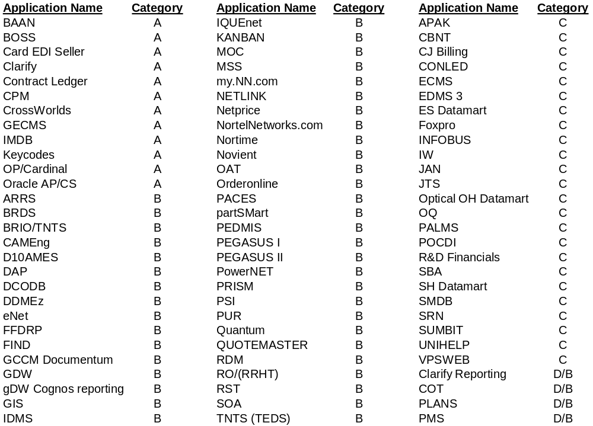

Appendix C – SWAT Documentation

All SWAT Team project and process information as well as management materials, statistical analysis, and staff profiling information is available on the Nortel Networks/CSC Livelink site at URL http://livelink2.ca.nortel.com/livelink/livelink.exe?func=ll&objId=1844980 . Note that access to the Nortel CORWAN will be required to access documentation

